Visualization

Architectural Spike

Cady Pridgeon

Laura Wilson

Amee Kivette

Keanna Tennyson

### COMP 4710 Senior Design Project #3 Team Orange

Department of Computer Science and Software Engineering

Samuel Ginn College of Engineering, Auburn University

January 29, 2024

Table of Contents

**1. Introduction 3**

1.1. Project Mission 3

1.2. System Metaphor 3

**2. Cycle Intent 3**

**3. Future Work 4**

**4. User Stories 4**

**5. Design Documentation 9**

5.1. Architecture 10

5.2. Structure 10

5.3. Interfaces 11

5.4. Assumptions & Dependencies 11

**6. Management Plan 11**

**7. Risk Mitigation 12**

**8. Lessons & Challenges 12**

8.1. Lessons Learned 12

8.2. Challenges Anticipated 13

**9. Meeting Minutes 13**

9.1. Introduction Meeting 13

9.2. Sponsor Correspondance 14

**10. Sponsor Approval 14**

# 

# Introduction

### Cady Pridgeon

The Alabama Authors of the 19th and 20th Centuries is a digital humanities project created by Dr. Beverley Park Rilett. This online resource provides access to information about Alabama authors and their published literature.

## Project Mission

The goal of the team is to enhance the Alabama Authors website with additional data visualizations. Currently, the only visualization on the project is a literary map. Dr. Rilett requested the addition of a chronology, similar to that of the one on her George Eliot Archive website. Thus, the mission of the Visualization Orange Team is to add a chronology that visualizes over 1,500 authors.

## System Metaphor

Data visualization is a remarkable feature of this project, currently in the form of a literary map and soon in that of a chronology. These visualization components are like a museum exhibit, allowing users to visually explore information before diving deeper into the details. While the map and chronology are the current visualizations available, there is potential to research additional exhibits to enhance the learnability of the rich information the project holds.

# Cycle Intent

**Laura Wilson, Cady Pridgeon**

The primary goal of this upcoming cycle is to develop a chronology data visualization for the Alabama Authors website. The website serves as a source of information about all of the authors from Alabama during the 19th and 20th centuries. As proven by Dr. Rilett’s George Eliot Archive resource, visualizations facilitate the learnability of the data for users. Thus, the team’s objective is to create an informative and interesting data visualization for the Alabama Authors project.

To accomplish this goal, the team will use Omeka Classic for data and content management and Reclaim Hosting for polishing the interface design. Omeka Classic contains plugins that can produce timeline visualizations. Together, these tools will support the team in creating a chronology.

# Future Work

**Keanna Tennyson, Cady Pridgeon**

Going forward, the team plans to research additional visualizations and improvements to incorporate into the website. After researching Omeka Classic plugins for the chronology visualization, a few plugins for graph visualizations were identified. These plugins could facilitate further visualizations for the project.

Accessibility and intuitive user experience are two priorities of the team. Since the primary target audience is professors and humanities academics, the user interface must be simple yet comprehensive. Subject matter experts will be very interested in the website content, but they also desire uncomplicated navigation. Thus, the team aims to conduct usability testing and ensure a wholly accessible interface that is WCAG and Section 508 compliant.

# User Stories

**Cady Pridgeon**

| **1.0 Chronology Data Visualization** | |
| --- | --- |
| Summary | As a user, I want to view authors on the Alabama Authors website in a chronology/timeline format to better explore and learn about the authors. |
| Description | Currently, the only visualization on the Alabama Authors website is a literary map. While this heatmap data visualization provides additional specific geographical context to the authors, a temporal visualization would also be interesting. This type of visualization enables users to explore the periods authors were alive and popular during to facilitate education, understanding, and research of the authors. |
| Planned Hours | Cycle: 0  Total: 40 |
| Actual Hours | Cycle: -  Total: - |
| Coder | - |
| Tester | - |
| Reviewer | - |
| Status | Not Started |

| **1.1 Chronology Data Visualization** | |
| --- | --- |
| Summary | As a user, I want to be able to see author names, birth years, death years, and picture when I hover over or select nodes to quickly learn about the author without having to navigate to their details page. |
| Description | Allowing users to see important information at a glance on the visualization supports their exploration and search of users. It also helps to differentiate nodes within the visualization. |
| Planned Hours | Cycle: 0  Total: 10 |
| Actual Hours | Cycle: -  Total: - |
| Coder | - |
| Tester | - |
| Reviewer | - |
| Status | Not Started |

| **1.2 Chronology Data Visualization** | |
| --- | --- |
| Summary | As a user, I want to be able to interact with author nodes on the visualization to access their details page, allowing me to quickly learn more about authors directly from the chronology. |
| Description | There are detailed pages for each author in the database, so it would support research and education about authors by permitting users to access these informative pages straight from a visualization. The current literary map supports this functionality. |
| Planned Hours | Cycle: 0  Total: 10 |
| Actual Hours | Cycle: -  Total: - |
| Coder | - |
| Tester | - |
| Reviewer | - |
| Status | Not Started |

| **1.3 Chronology Data Visualization** | |
| --- | --- |
| Summary | As a user, I want to be able to filter the visualization based on criteria, such as birth years and names, to customize my exploration of relevant information. |
| Description | Including filtering functionality better equips users for efficient data exploration. Without it, users may feel frustrated or experience cognitive overload if they are unable to access information of interest quickly and effectively. |
| Planned Hours | Cycle: 0  Total: 15 |
| Actual Hours | Cycle: -  Total: - |
| Coder | - |
| Tester | - |
| Reviewer | - |
| Status | Not Started |

| **1.4 Chronology Data Visualization** | |
| --- | --- |
| Summary | As a user, I want to be able to export my visualization to keep for my records to conduct research or simply save my findings. |
| Description | Being able to quickly export a complex visualization into an image or PDF supports users in research and grants them a way to save progress after utilizing visualizations on the website. |
| Planned Hours | Cycle: 0  Total: 10 |
| Actual Hours | Cycle: -  Total: - |
| Coder | - |
| Tester | - |
| Reviewer | - |
| Status | Not Started |

| **1.5 Chronology Data Visualization** | |
| --- | --- |
| Summary | As a user, I want to view all of the Alabama authors from the 19th and 20th century to gain a complete picture of the literary landscape from this area and time. |
| Description | Currently, the website includes 150 authors in its literary map visualization and detail pages. However, there are around 1,500 data entries for authors from this time, so it is important to include these additional data points for completeness. |
| Planned Hours | Cycle: 2  Total: 5 |
| Actual Hours | Cycle: 1  Total: - |
| Coder | Cady Pridgeon |
| Tester | - |
| Reviewer | - |
| Status | In Progress |

| **1.6 Chronology Data Visualization** | |
| --- | --- |
| Summary | As a user, I want to be able to access the Alabama Authors website from any device, such as a computer, tablet, or phone, and experience an accessible data visualization. |
| Description | The data visualization should be responsive, supporting users from any device, including a mobile phone. |
| Planned Hours | Cycle: 0  Total: 10 |
| Actual Hours | Cycle: -  Total: - |
| Coder | - |
| Tester | - |
| Reviewer | - |
| Status | Not Started |

| **1.7 Chronology Data Visualization** | |
| --- | --- |
| Summary | As a user, I want to experience an accessible user interface on the Alabama Authors website to ensure my abilities do not interfere with viable interactions on the website. |
| Description | Color contrast, tab index, and verbiage are a few aspects that make an interface accessible and inclusive. It is crucial that anyone, regardless of their abilities, should be able to access and navigate the website and visualizations with ease. |
| Planned Hours | Cycle: 0  Total: 10 |
| Actual Hours | Cycle: -  Total: - |
| Coder | - |
| Tester | - |
| Reviewer | - |
| Status | Not Started |

| **1.8 Chronology Data Visualization** | |
| --- | --- |
| Summary | As an administrator, I want to be able to manage the chronology/timeline data visualization with Omeka Classic to avoid issues with GitHub repository connections. |
| Description | Sometimes data visualizations are connected to the digital humanities websites by hosting the visualization on a GitHub repository and displaying the result on the website with an iframe. However, this is a frustrating solution for site administrators, since they often run into permissions and security restrictions. To prevent this, we must create our visualization using plugins supported by Omeka Classic. |
| Planned Hours | Cycle: 3  Total: 10 |
| Actual Hours | Cycle: 3  Total: - |
| Coder | Cady Pridgeon |
| Tester | - |
| Reviewer | - |
| Status | In Progress |

| **2.0 Author Details Page** | |
| --- | --- |
| Summary | As a user, I want to view an author's date of birth and date of death on their details page to quickly remember the period they lived through. |
| Description | While users can view an author's date of birth on data visualizations, their birth date and death date are missing from their detail page. This could frustrate users by creating an inconsistency in data availability over various pages on the site. |
| Planned Hours | Cycle: 0  Total: 10 |
| Actual Hours | Cycle: -  Total: - |
| Coder | - |
| Tester | - |
| Reviewer | - |
| Status | Not Started |

# Design Documentation

**Cady Pridgeon**

## Architecture

This project uses Omeka Classic and Reclaim Hosting for management and hosting. Omeka Classic is a content management system for archives and educational collections. This is where site administrators can go to add, update, and remove data. Since the subject matter experts for this website are primarily academics in the humanities, it is user-friendly and non-technical. Reclaim Hosting facilitates web hosting for educational institutions. This is where the website design controls are located.

On Omeka Classic, a CSV file containing Alabama Authors entries can be uploaded and parsed. This file contains the following fields for each author:

* Author_Last_Name_First_Name
* Author_First_Name_Last_Name
* BirthDate
* DeathDate
* Author_Biography
* Source
* Book_Publications

After Omeka Classic stores the data in structured objects representing Alabama authors, they can be passed into various formats, such as a page or plugin.

## Structure

Omeka Classic allows the use of supported plugins to facilitate data parsing and visualization on a website. During technical research, the following plugins were identified as possible means by which a chronology could be created within Omeka Classic:

* Timeline
* Neatline Time

Two additional plugins, AvantRelationships and Archiviz, were identified for possible data visualization in a graphical format. If time permits, these could be interesting visualization options to increase data exploration capabilities.

The Alabama author data could be processed by these plugins, creating a data visualization that would appear on the website. Users could then interact with the visualization, exploring data on a chronology or timeline.

## Interfaces

The primary interactions in this project are the data with Omeka Classic, Omeka Classic with Reclaim Hosting, and administrators with the data. Within Omeka Classic, there are interactions between the data and plugins that facilitate data visualization.

In the past, visualizations have been hosted on GitHub repositories and displayed on the site using an iframe. However, this solution is to be avoided, since it causes issues for administrators and is considered a minimally viable product.

## Assumptions & Dependencies

This model assumes that the primary data source is the CSV of Alabama authors. However, there are additional data sources, namely a collection of literary works by the authors. Currently, it is not in the project scope to interface with this data, but if time permits, additional visualizations regarding this dataset may be investigated.

The success of this cycle relies on the flexibility and comprehensiveness of the plugins available on Omeka Classic. Since the sponsors advise avoiding creating a visualization hosted on GitHub, the team is limited to the capabilities available on Omeka Classic. While some plugins seem promising, others appear outdated and plain. If the team is unable to produce a viable visualization, they may need to explore the possibility of GitHub hosting, although it is a minimally viable product solution.

# Management Plan

**Keanna Tennyson, Cady Pridgeon**

For team communication, group messages, email, and Zoom are utilized. These mediums of communication allow for quick discussion of project matters. To coordinate with Dr. Rilett, the team uses email, Zoom, and in-person meetings to discuss weekly progress and tasks.

To organize and schedule team meetings, Microsoft Excel is used. The cycle status reports also help the team with productivity and time management.

To manage user stories and tasks, a Kanban taskboard is leveraged. The team has a shared workspace on Notion where an Agile-style development process is carried out.

For the code base, Omeka Classic is used for content management and data import. Reclaim Hosting houses the user interface design and controls.

# Risk Mitigation

**Laura Wilson, Cady Pridgeon**

The project sponsors identified risks associated with a common approach to data visualization in similar projects. In previous semesters, students hosted their visualizations on the site by creating their projects on GitHub and utilizing iframes to display their work. However, the project developer warned that this approach leads to security and permissions issues down the road. Thus, the team is attempting the project with Omeka Classic plugins to offer a visualization within the current content management system.

Unfortunately, many of these plugins are not very flexible or modern. In the case that these plugins cannot produce an adequate visualization, the sponsor approved that our team could utilize the GitHub hosting approach to complete the project. The team will do everything possible to avoid this solution since it is inadvisable.

# Lessons & Challenges

**Amee Kivette**

## Lessons Learned

Because this project is in its infancy, experiences lending toward growth are still limited. Despite the limited experiences thus far, regular communication, clear expectations from sponsors, and an understanding of inherent limitations have proven to be vital in these early stages of research and planning. During research before meeting with Dr. Rilett, the team discovered projects utilizing GitHub for visualizations. The team expected to follow a similar path to previous projects, but the new constraint of Omeka Classic plugins limited flexibility.

## Challenges Anticipated

Initial challenges that have arisen in the early stages of planning, research, and design include determining a clear path toward a maximal viable product while also giving appropriate consideration to ensure maintainability in the long run. Because the roles of administrators and sponsors are primarily filled by librarians and historians, it is important to prioritize the continuity of the project by ensuring that maintenance is feasible and within their scope of knowledge. A challenge that could be anticipated as this project progresses is potential design limitations for developers when using content management systems designed for librarians and historians.

# Meeting Minutes

**Amee Kivette**

## Introduction Meeting

**Visualization: Orange Team**

[Alabama Authors Website](https://alabamaauthors.org/)

Thursday, January 25, 2024

**Attendees**

Dr. Rilett, *Sponsor*

Brad Hughes, *Web Developer*

Yue Cui*, Consultant*

Cady Pridgeon*, Team Member*

Laura Wilson*, Team Member*

Keanna Tennyson*, Team Member*

Amee Kivette*, Team Member*

**Agenda**

Last Meeting Follow-up

* N/A

New Business

* Proposed Product: Add interactive chronology/timeline or other visualization containing authors’ names, birth years, and images.

**Notes/Resources**

[Alabama Authors Spreadsheet](https://auburn.app.box.com/file/1237945593670?s=fickaow6onbfo3mrhfe2ryymdv9ubc8t)

* Listed under “For Our Larger Project”
* Only need names and dates of birth

George Eliot Archive: <https://georgeeliotarchive.org/>

Zoom: <https://auburn.zoom.us/j/4813826190>

Reclaim

* <https://www.reclaimhosting.com/>
* <https://cpanel.net/>

Access to [Alabama Authors Admin](https://alabamaauthors.org/admin/users/login) has been granted.

* login will be AU login (example: aub0001)
* password will be the same as login

**Next Meeting Agenda Items**

* Check in/Status update
* What is everyone’s preferred method of sharing and organizing documents and other important info?

## Sponsor Correspondance

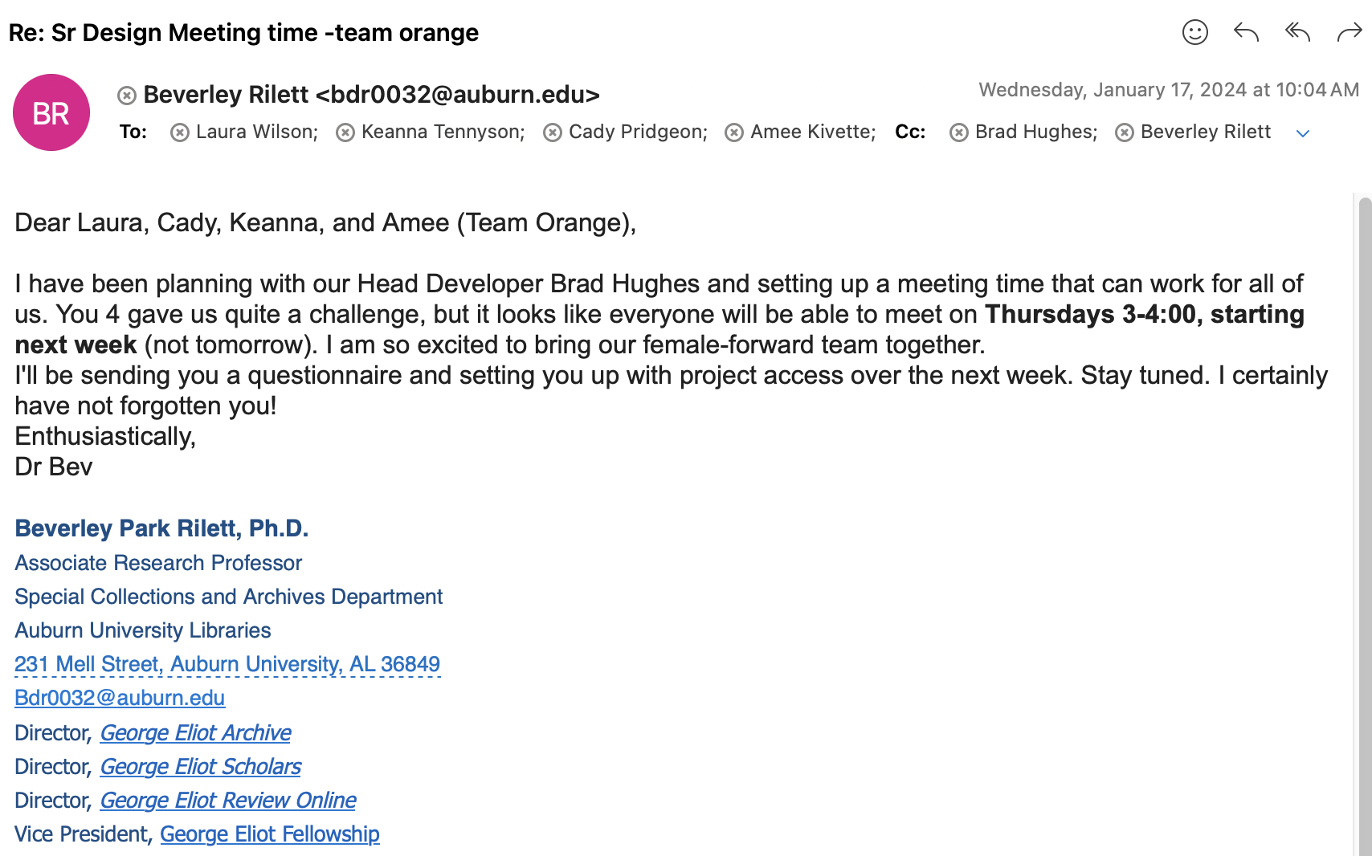

# Sponsor Approval

Our sponsor approves this report and endorses our work as presented.

______________________________________________________________________________